## **Hands-On Activity: Creating, filtering, and customizing charts**

**TOTAL POINTS 2**

1.

Question 1

## Activity overview



You have learned that you can create charts in spreadsheets and in Tableau, and that you can customize the information displayed in them using filters. Before working in Tableau, you will work with the spreadsheet chart editor.

By the time you complete this activity, you will be able to create a chart in a spreadsheet and customize it by using filters and applying different styles. This will enable you to use spreadsheets in another helpful way, which is important for using all the tools at your disposal in your career as a data analyst.



### What you will need

To get started, first access the sample data.

To use the data for this course item, click the link below and select “Use Template.”

Link to sample data: [Cosmetics Inc.](https://docs.google.com/spreadsheets/d/1qaSKSyfvXz3Zsu_RU7abK-eNScSyGSe2oXT1KgiaMXI/template/preview)

OR

If you don’t have a Google account, you can download the template directly from the attachment below.

[Cosmetics Inc..xlsx](https://d3c33hcgiwev3.cloudfront.net/1CatA2d3QAqmrQNndzAKQg_420b4adfcdec47a0b0c67d6c5cea0641_Cosmetics-Inc..xlsx?Expires=1623628800&Signature=Og9bmZxe2y7TduU5E62mo9voUwJ7SLR5bezVkE0f2vsTQlfxG9B3nFQMecos7ovLQoIya55SH4Fk4KupdxnRjieQTPsbeXbvExA8q6anxsj~At8xJjq-zSDyucxNsSyrJ4DgiLsMWWxXdp41DgvsnHBZoOdrX-nl2~WSm9HxNDM_&Key-Pair-Id=APKAJLTNE6QMUY6HBC5A)

[](https://d3c33hcgiwev3.cloudfront.net/1CatA2d3QAqmrQNndzAKQg_420b4adfcdec47a0b0c67d6c5cea0641_Cosmetics-Inc..xlsx?Expires=1623628800&Signature=Og9bmZxe2y7TduU5E62mo9voUwJ7SLR5bezVkE0f2vsTQlfxG9B3nFQMecos7ovLQoIya55SH4Fk4KupdxnRjieQTPsbeXbvExA8q6anxsj~At8xJjq-zSDyucxNsSyrJ4DgiLsMWWxXdp41DgvsnHBZoOdrX-nl2~WSm9HxNDM_&Key-Pair-Id=APKAJLTNE6QMUY6HBC5A)

## Creating a chart in a spreadsheet



Important note: The following steps are for Google Sheets but they can help guide you to similar features in Excel. Refer to the Additional resources section if you need more specific instructions for creating charts in Excel.

1. In the spreadsheet that you copied or downloaded, practice creating a chart by clicking the second tab named Create your chart here. This tab contains the total purchases calculated for each store from the first tab. All of the original data is preserved in the first tab so you can explore chart creation in the second tab without changing or deleting any of the original data.

2. Highlight cells B3 through C7 as the data for your chart.

3. From the main menu, click Insert, and select Chart.

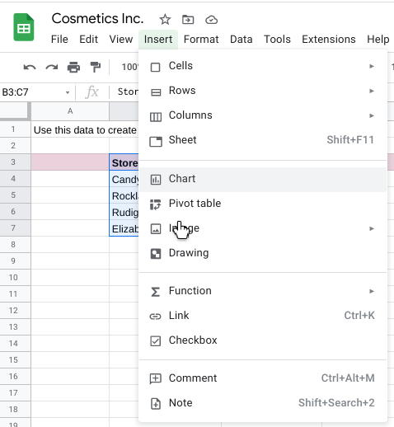

4. A chart is created automatically and a chart editor opens on the right so you can change the chart type. If a pie chart is displayed, click the Chart type drop-down and select a column chart so your chart looks like the one below.

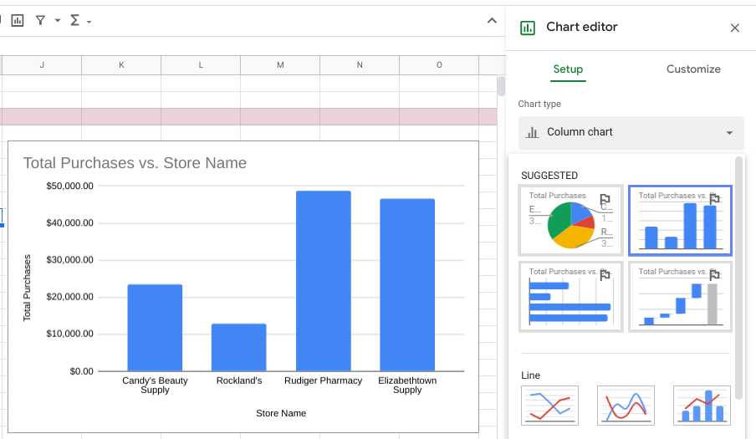

5. To filter the data shown in the column chart, make sure the pink row 3 is highlighted and then click the filter icon in the toolbar. (The filter icon is the second icon from the right in the toolbar.) This adds a filter icon in each column of your data.

6. Click the filter icon for Store Name and uncheck Candy's Beauty Supply.

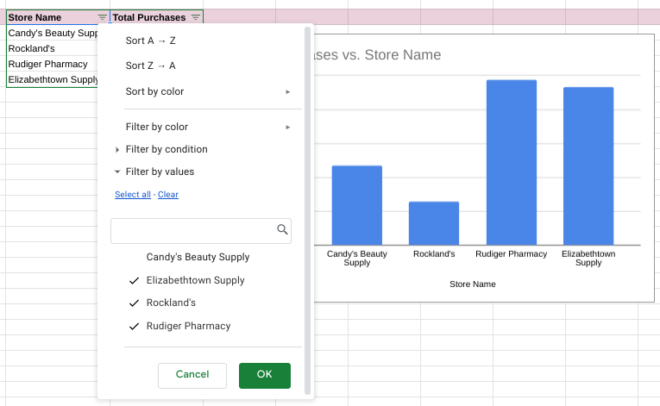

7. Click OK and your chart will automatically update to exclude the data for Candy's Beauty Supply, as shown below.

Note: To include the data for Candy's Beauty Supply again, simply click the filter icon for Store Name and click Candy's Beauty Supply to add the check mark back.

### Applying Styles



You can also apply different styles to the chart. For example, the default blue in the chart isn't the most appropriate for accessibility when the background is white.

1. Double-click the chart to open the chart editor.

2. Click Series in the chart editor to expand the options.

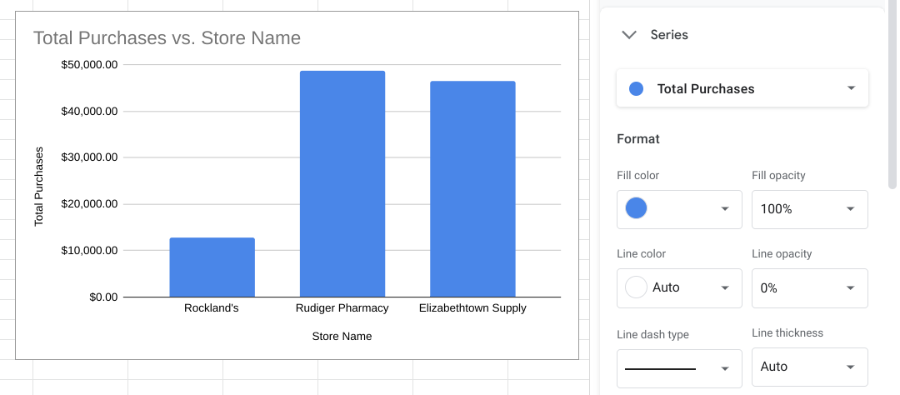

3. Under Format, click the drop-down for Fill color, and select Custom.

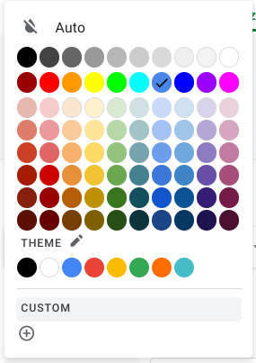

4. Change the Hex value for the color from #4a86e8 to one of the blue hues recommended for use on white backgrounds for accessibility. [Carnegie Museums of Pittsburgh's accessibility guidelines](http://web-accessibility.carnegiemuseums.org/design/color/) are an example of web accessibility guidelines.

* #0071bc
* #046b99
* #205493

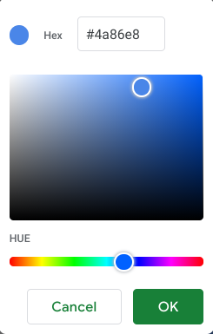

5. Click OK and the chart will automatically update with the newly assigned color.

## Additional resources



Here are a few more resources you can reference as you learn more about charts in spreadsheets:

* [Graphs in Google Sheets](https://www.datacamp.com/community/tutorials/graphs-in-spreadsheets): Not only does this resource contain a detailed example of chart creation in spreadsheets, but it also provides you with downloadable sample data you can use to practice. As you have learned throughout this course, practicing these skills helps you learn more about the tools you are using. This example data is a great way to start!
* [Add and edit a chart or graph in Google Sheets](https://support.google.com/docs/answer/63824): This article includes steps for creating, editing, and changing charts in Google Sheets with how-to videos. It also has a more in-depth guide to editing and customizing your chart after you have created it.
* [Create a Microsoft Excel chart from start to finish](https://support.microsoft.com/en-us/office/create-a-chart-from-start-to-finish-0baf399e-dd61-4e18-8a73-b3fd5d5680c2): This how-to guide from Microsoft’s support site includes instructions and a video tutorial for adding charts to Excel spreadsheets. This is a useful resource if you are working specifically with Excel spreadsheets. It also links to other useful articles about creating charts in Excel.

[Microsoft Excel: Creating and modifying charts](https://guides.lib.umich.edu/c.php?g=283162&p=1886446): This is an explanation of Excel charts with downloadable handouts. This resource is especially useful because it has downloadable content that you can save to reference later when you start creating charts in your own spreadsheets.

## Confirmation and reflection



Which changes can you make to customize a chart in a spreadsheet? Select all that apply.

**1 / 1 point**

Animate the chart by using the Multimedia drop-down

Change the chart colors by using the Series drop-down

**Correct**

To customize a chart in a spreadsheet, you can change the colors, data, and type of chart. Going forward, you can apply your knowledge of charts to future lessons about data visualization. This will help you prepare for future lessons about data visualization.

Change the chart’s data by updating relevant cells

**Correct**

To customize a chart in a spreadsheet, you can change the colors, data, and type of chart. Going forward, you can apply your knowledge of charts to future lessons about data visualization. This will help you prepare for future lessons about data visualization.

Change the chart type by using the Chart type drop-down

**Correct**

To customize a chart in a spreadsheet, you can change the colors, data, and type of chart. Going forward, you can apply your knowledge of charts to future lessons about data visualization. This will help you prepare for future lessons about data visualization.

2.

Question 2

During this activity, you created a chart within a spreadsheet. In the text box below, write a 2-3 sentence (40-60 words) response to each of the following questions:

* What are some advantages and disadvantages of creating a chart directly in a spreadsheet?
* How did this activity build your knowledge of spreadsheets and data visualization?

**1 / 1 point**

for a small data the advantage is that you don't have to worry about long process the process is simple.

**Correct**

Congratulations on completing this hands-on activity! A good response would include how the spreadsheet chart editor is a simple and convenient way to visualize data. Beyond that, consider the following:

Data analysts use spreadsheets for a variety of data analysis tasks, including creating charts. What you’ve learned about visualizations in spreadsheets you can apply to dashboard visualizations. In upcoming activities, you will use this knowledge in Tableau, another data visualization platform. This will help you practice more data visualizations—an essential tool in every data analyst’s toolkit.